PHASE 6
PROJECT TESTING
Introduction:
TEAM ID : SWTID-2026-4524
TEAM LEADER: NOWSHATHULLAH A
MAIL ID : nowshath212007@gmail.com
Team members:
NAME: | MAIL ID:
Nagaraj E | nagarajmbbs1903@gmail.com
MuthuKumar S | muthusmart222@gmail.com
Priyan A | priyanstar702@gmail.com
The project documentation states that the REST APIs can be tested using Postman or Thunder Client. The supplied screenshots are included below as testing evidence.

Register API
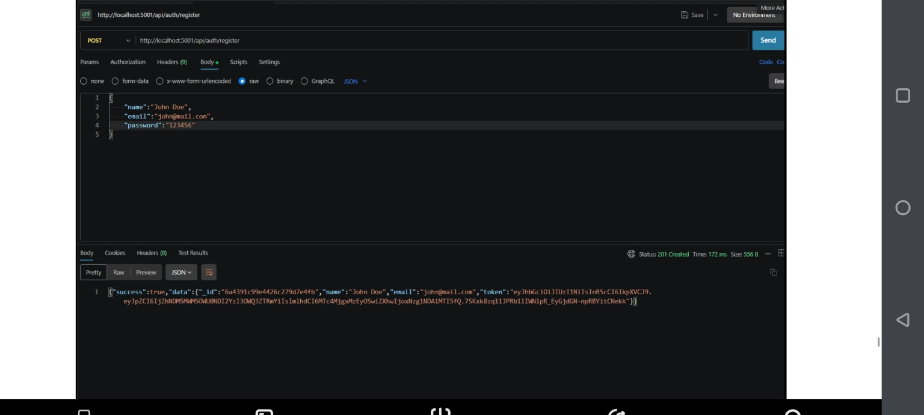
Register API — HTTP 201 Created

Weather API
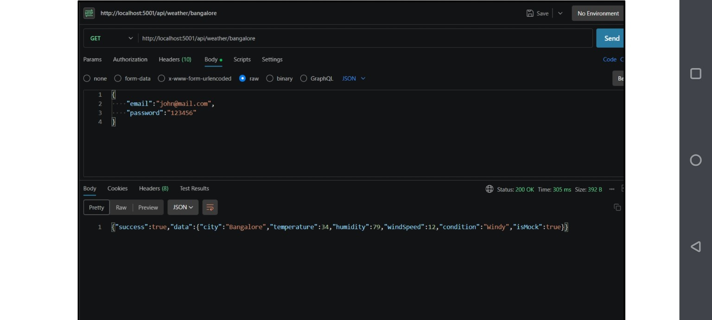
Weather API — HTTP 200 OK

Recommendation API
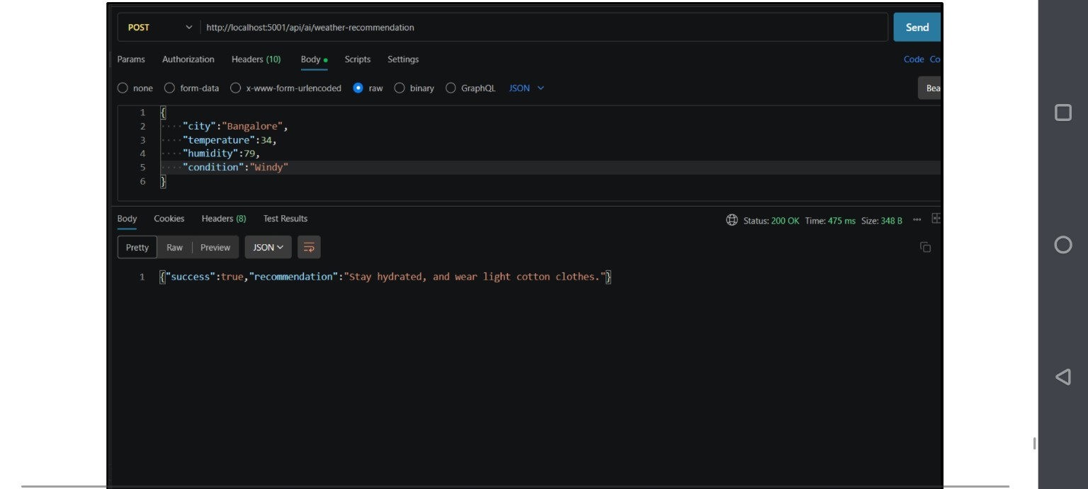
Weather Recommendation API — HTTP 200 OK
Testing result: the supplied screenshots show successful API responses for registration, weather retrieval and weather recommendation. The original documentation also lists Login API testing.

